**User’s Manual**

**Get Rid Of It**

**Table of Contents**

A. GENERAL INFORMATION: 3

1.1 System Overview 3

1.2 Organization of the Manual 3

B. HOME SCREEN 4

2.1 Footer Links: 4

2.1.2 FAQ 4

2.1.2 Contact Us 5

2.1.3 Return Policy 5

C. USER PANEL 7

3.1 Sell Tab 7

3.2 How It Works Tab 7

3.3 My Account Tab 8

3.4 Settings 9

D. ADMIN PANEL 10

4.1 Dashboard 10

4.2 Users 11

4.3 Items 11

4.4 Message Board 12

4.5 Issues 12

# A. GENERAL INFORMATION:

## 1.1 System Overview

Get Rid of It is an online auction site that allows users to sell old or unused items to Gold Standard Auctions. Users are able to negotiate their offers made by Gold Standard Auctions and may freely choose to accept or decline offers. This website currently has no option for users to buy items from other users.

## 1.2 Organization of the Manual

The user’s manual consists of three sections: Home Screen, User Panel and Admin Panel.

The Home Screen is the first page users will interact with. Users may choose to create an account, login if the user already exists, and check out important information to learn more about Gold Standard Auctions’ policies.

The second section is the User Panel, where users can submit items, see their offers and accept them, and send direct messages to the admin.

Finally, the Admin Panel is where the admin can see the users, their messages and items, and create responses for them.

# B. HOME SCREEN

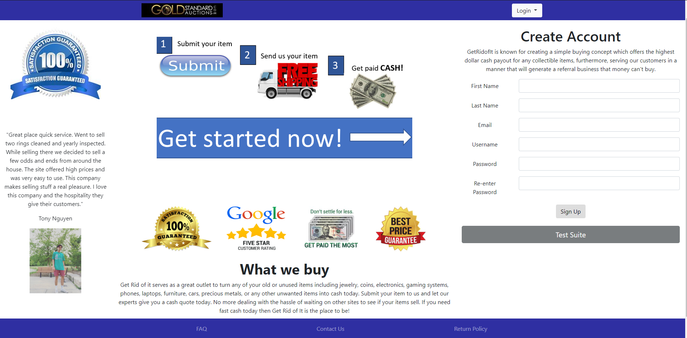

The first page users will interact with is the home screen. On the home screen, users may choose to create an account or login if the user already exists. Also, people who are not users of the page can access to the footer links

## 2.1 Footer Links:

### 2.1.2 FAQ

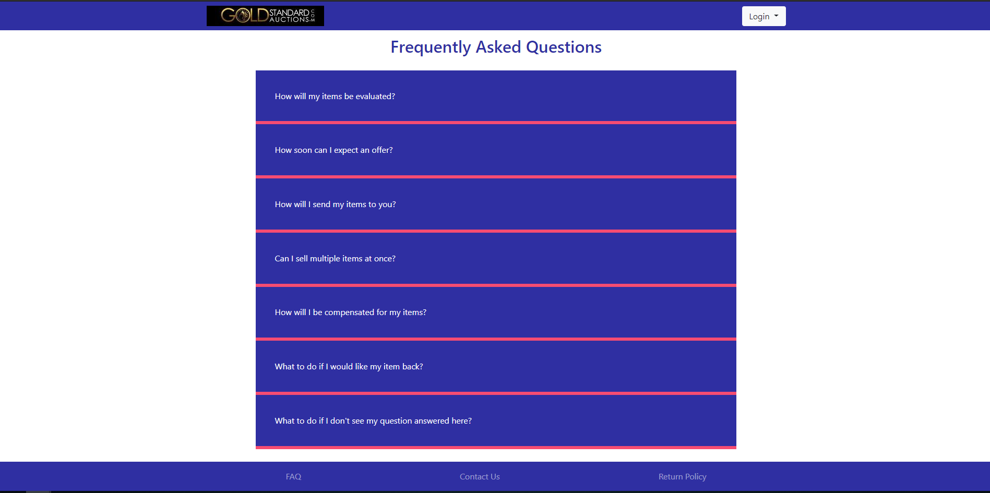

The first footer link contains Gold Standard Auctions’ frequently asked questions (FAQ). On this page, users can find important information in regards to selling their items.

### 2.1.2 Contact Us

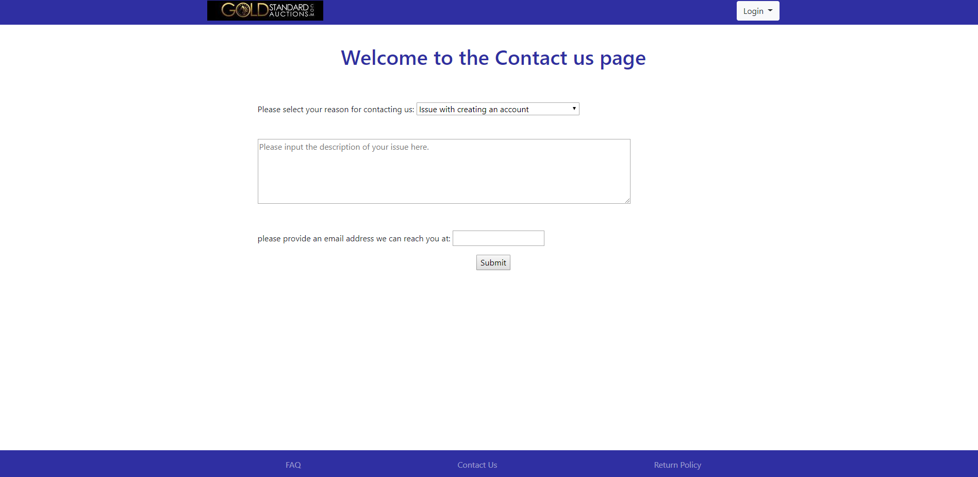 The second footer link contains a form for users to submit their questions not found on the FAQ. These could be any question the user has which will be sent to the website’s admins. All it requires is an existing email for admins to get in touch with.

### 2.1.3 Return Policy

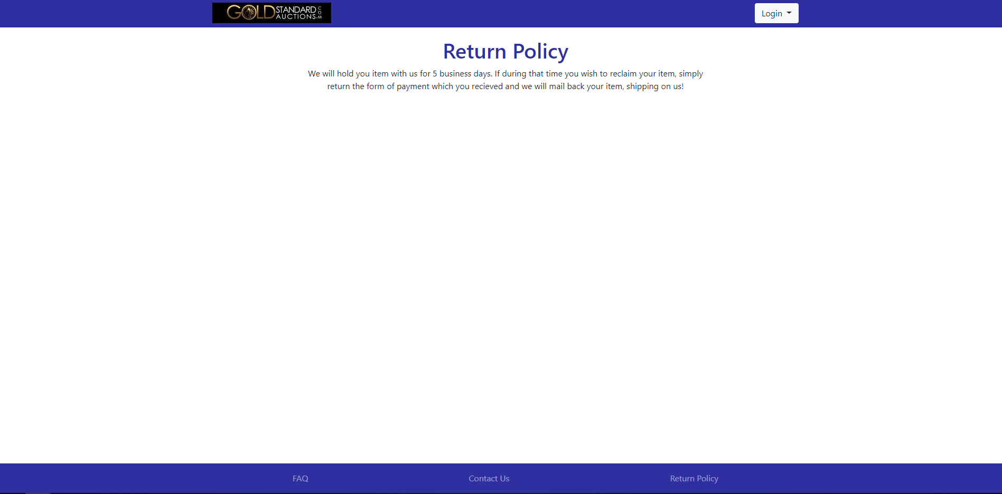

The third footer link contains a message that informs users about the return policy with Gold Standard Auctions.

# C. USER PANEL

## 3.1 Sell Tab

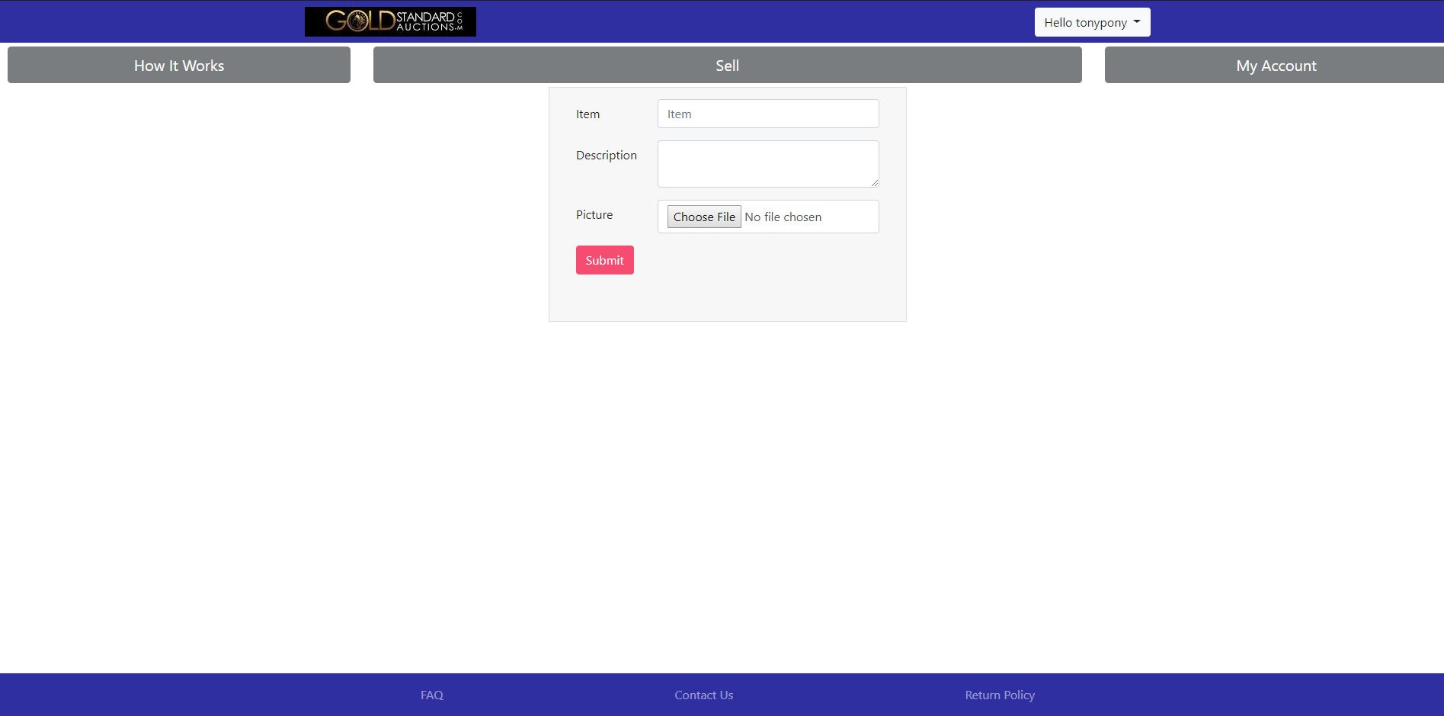

After a new user has created an account, they may login from the home screen. Once the user is logged in, they will instantly see three tabs in which the user can interact with. It defaults the user to the ‘Sell’ tab which requires an item, description of the item, and the picture of the item. Once users submit an item that they want to sell, they must wait until an admin makes an offer.

## 3.2 How It Works Tab

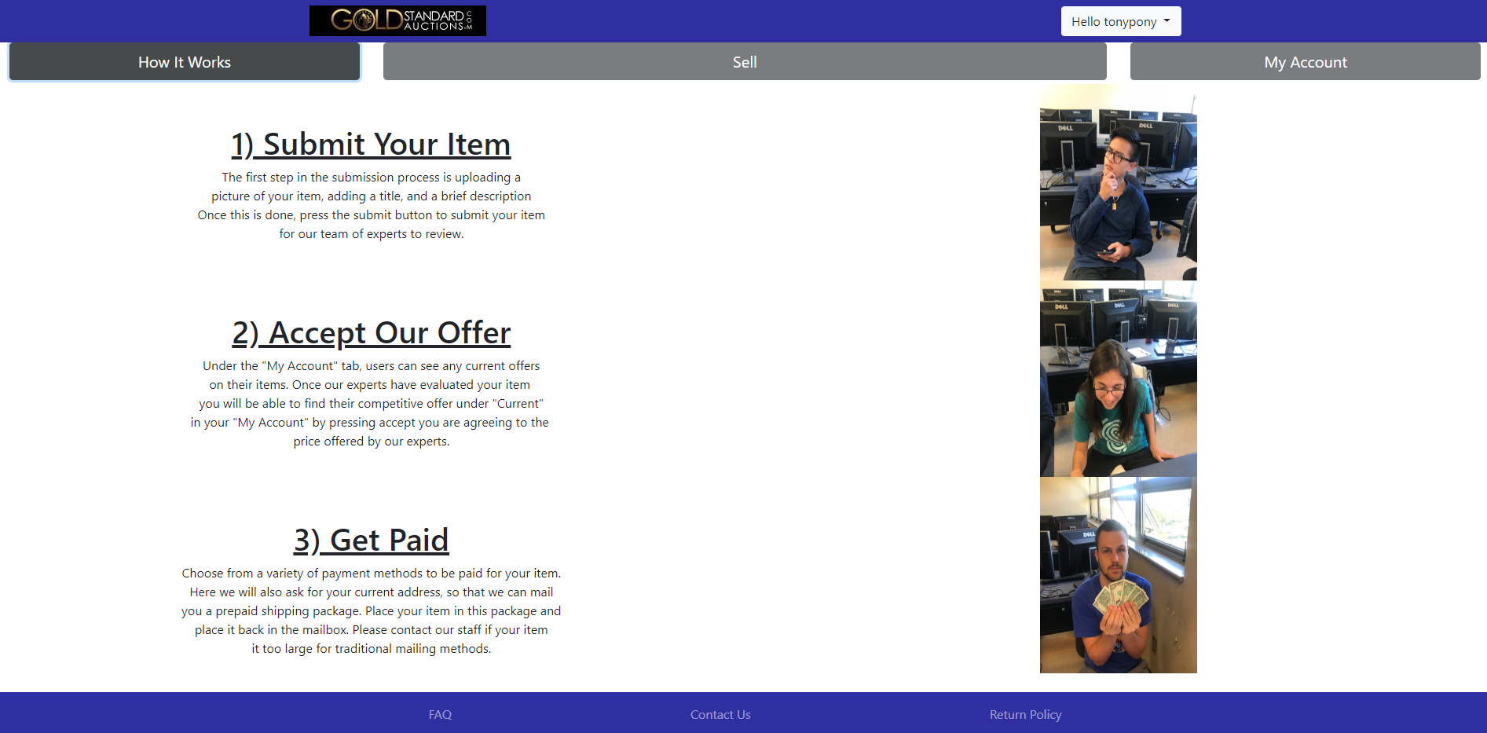

This tab is a short tutorial for users to navigate through the user panel. Users may submit items, accept offers, and receive a payment.

## 3.3 My Account Tab

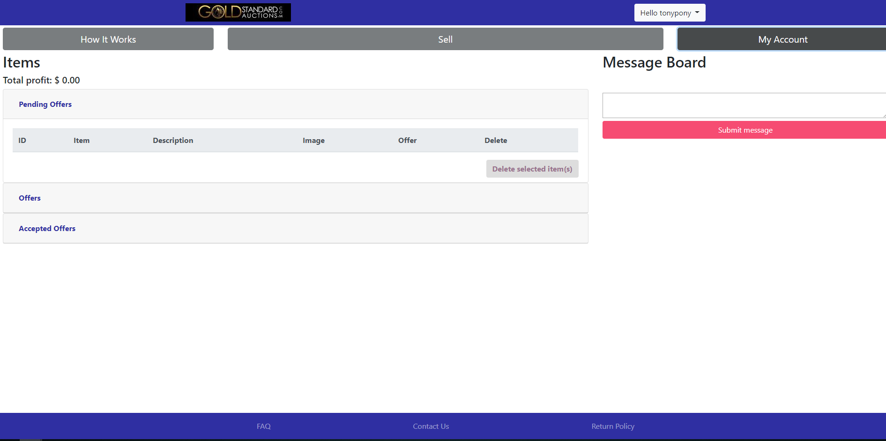

The ‘My Account’ tab is arguably one of the most important tabs for users. It allows users to see their pending offers (offers not seen by the admin yet), offers made by an admin, and already accepted offers. There is also a message board that allows users to negotiate their offers with an admin as well. Not only can users see the results of their offers, they may delete their items and see how much profit they receive from accepting offers.

## 3.4 Settings

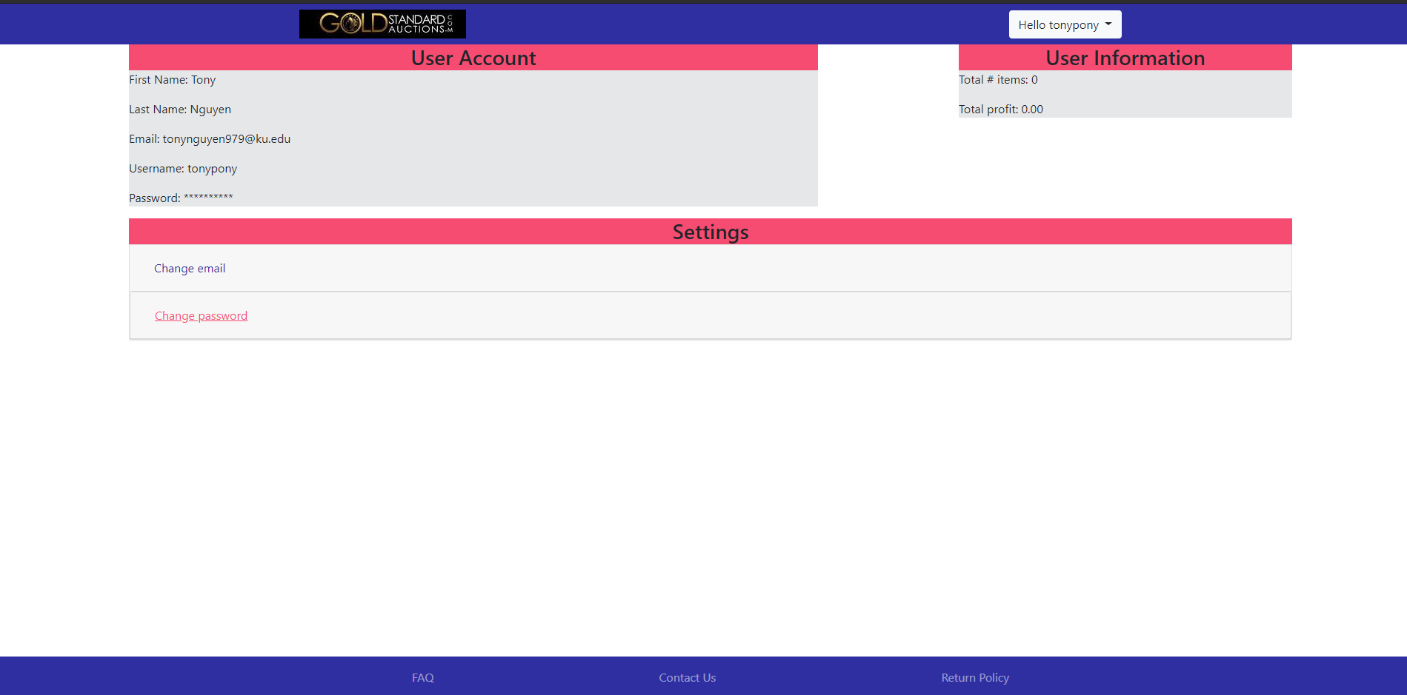

On the top right hand corner, there is a button that contains a username. By clicking on that button, users may log out, go to the home screen, or view the settings page. The settings page contains the user’s information regarding items sold and personal credentials. A user may also choose to change the email and/or password associated with their account.

# D. ADMIN PANEL

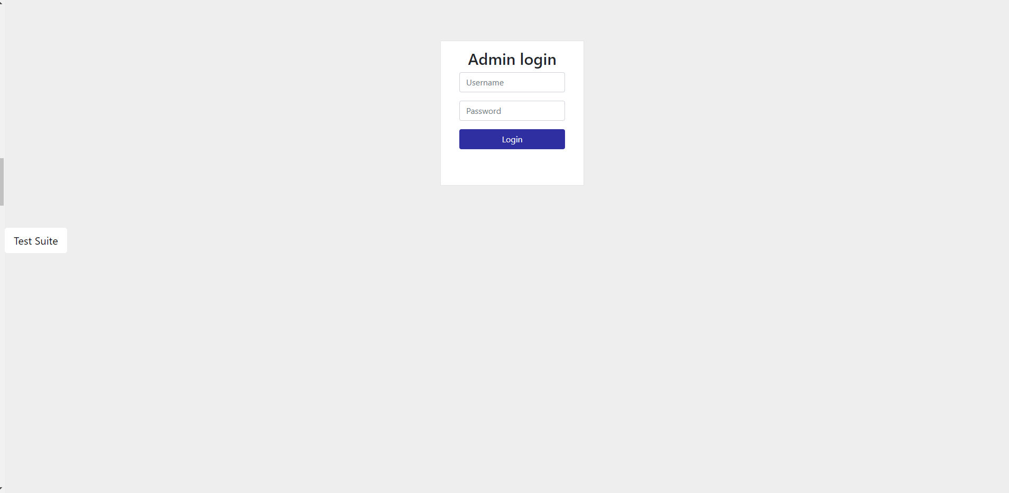

On the admin panel, Gold Standard Auctions’ admins are presented with a login screen. Here is where an admin can enter their credentials and access their admin responsibilities.

## 4.1 Dashboard

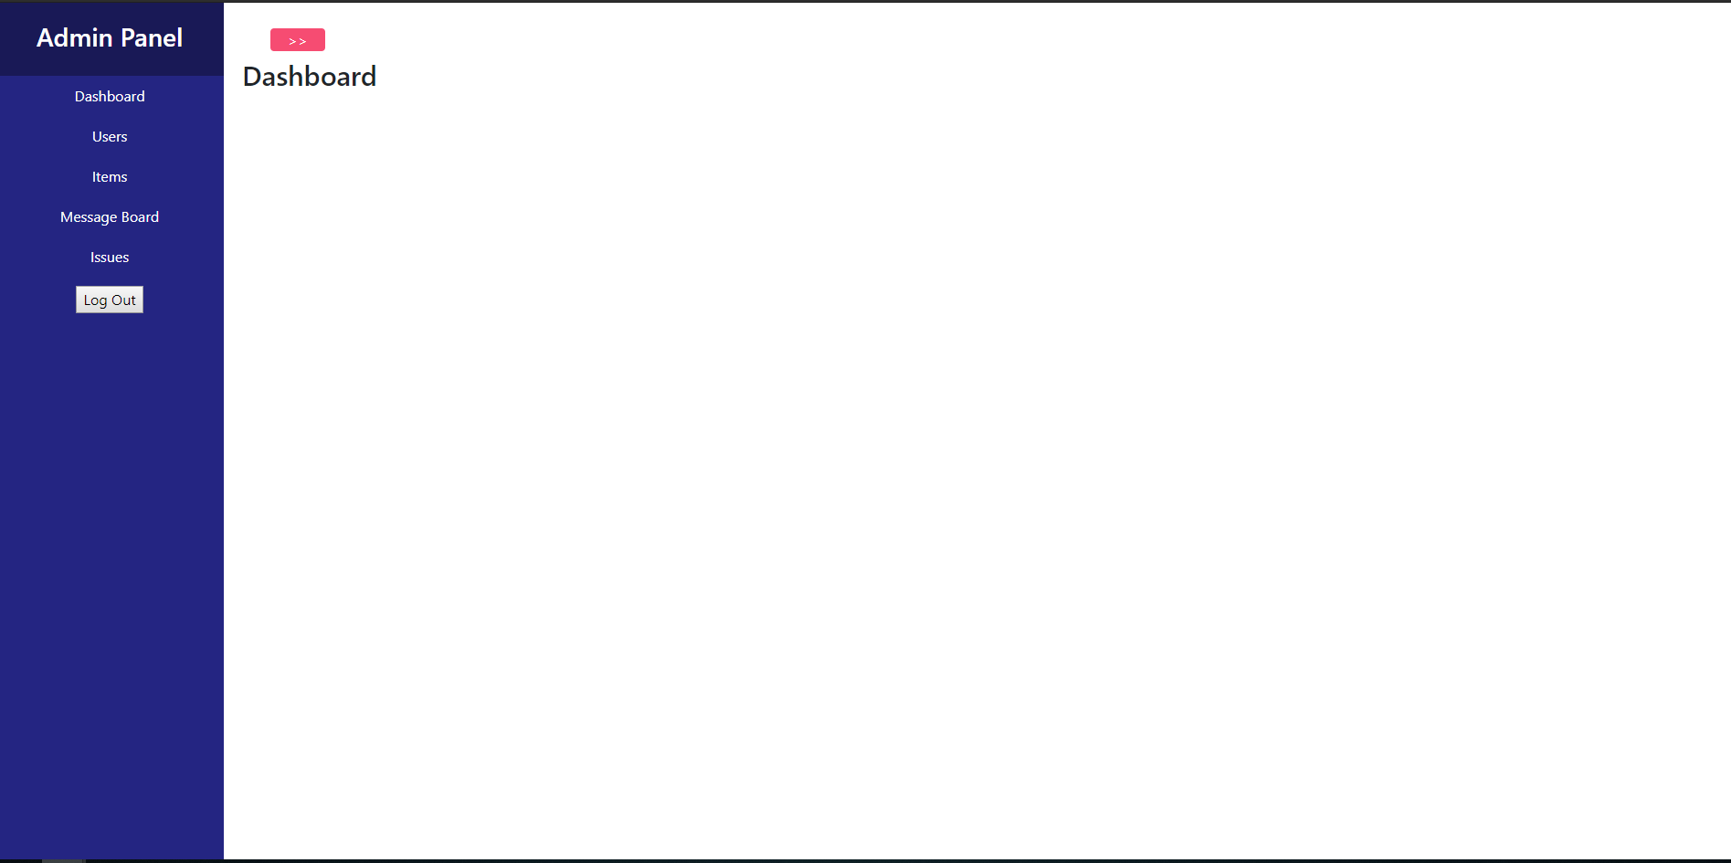

After logging in on the admin panel, admins are presented a dashboard with a sidebar that contains different components for an admin to interact with. These components include viewing existing users, existing items, messaging between admins and users, and messaging submitted from the ‘contact us’ page.

## 4.2 Users

## 

On the Users tab, admins can view a user’s profile and submit a message. Admins can also view the number of items each user submits and has the power to delete a user.

## 4.3 Items

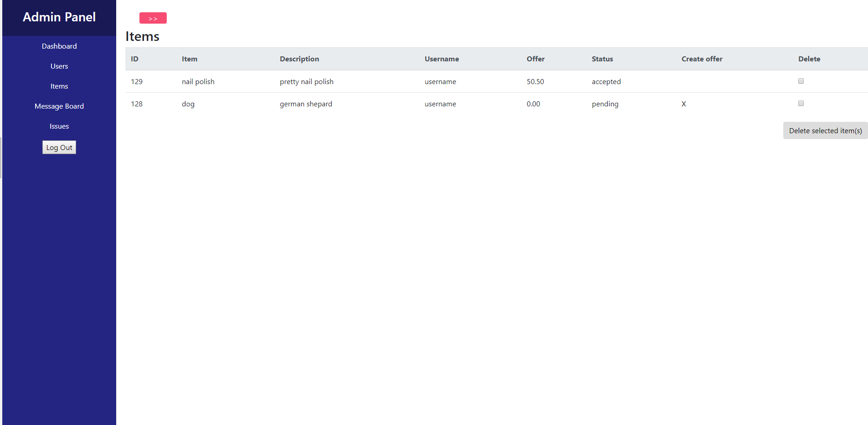

On the Items tab, admins can create an offer for each item a user presents. Admins can also see the status of each offer and may delete an item.

## 4.4 Message Board

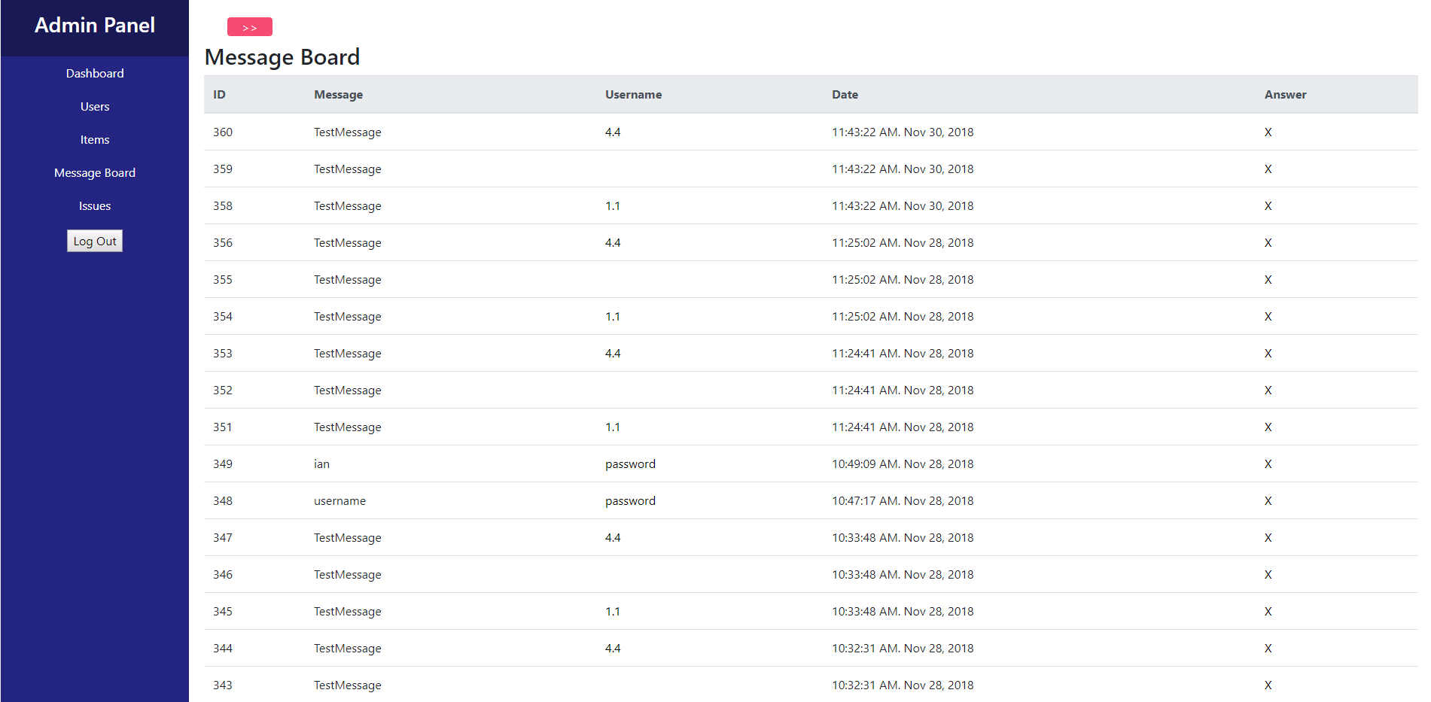

On the Message Board tab, admins can reply to a specific user’s message and view the date of each message.

## 4.5 Issues

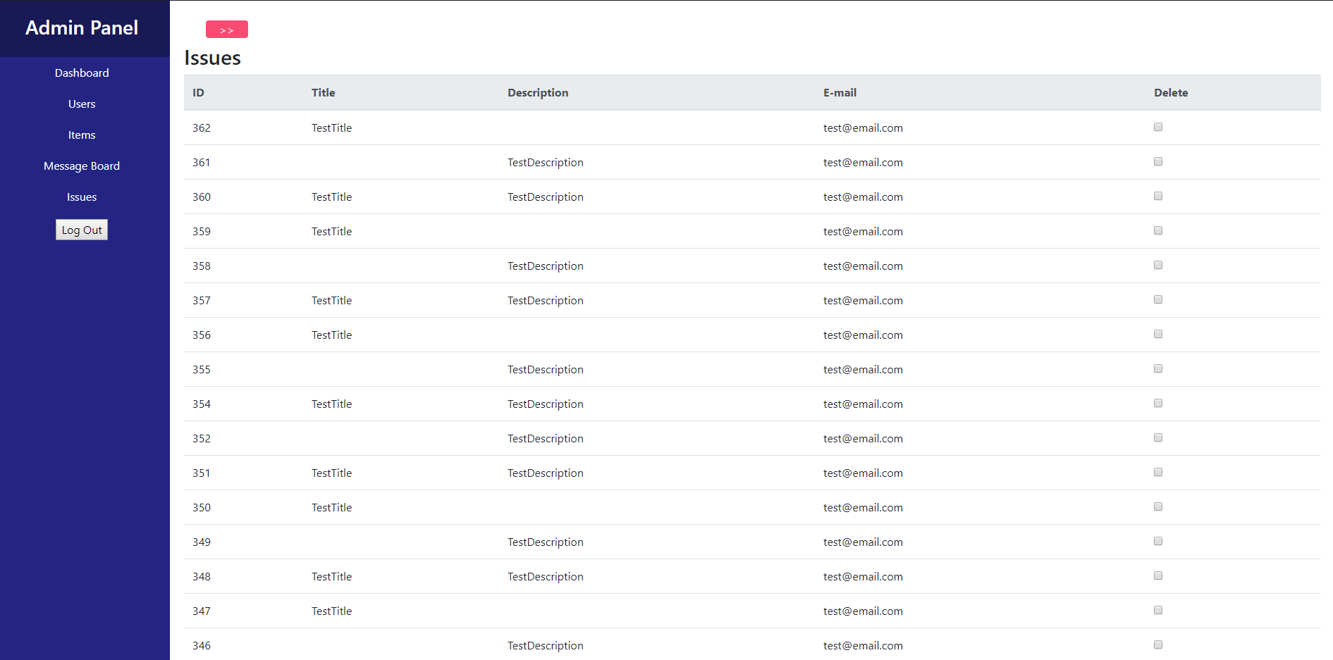

On the Issues tab, admins view and delete messages submitted from the ‘contact us’ tab.